Deployment Guide

## Table of contents

Quick Start

How to Create the Database

Production Deployment on Google Cloud Platform Instructions

## Quick Start

Welcome to Conestoga Provincial Park! Let's get you up and running with our rental platform in the simplest configuration possible. We use Node.js and Express for the backend, and javascript/html/css for the frontend.

**Prerequisites:**

1. **Docker setup** : make sure your machine has docker command installed.

**MySQL database:**

1. **Use your preferred mysql client software to login your mysql database**
2. **Apply the sql query file to generate all required schema**<https://github.com/Smars-Bin-Hu/capstone-project-dev/blob/feature/database/conestoga-provincial-park-ddl.sql>
3. **Apply the sql query file to Insert trail information for the trails**  
   <https://github.com/Smars-Bin-Hu/capstone-project-dev/blob/feature/database/conestoga-provincial-park-trail-data.sql>

**Backend and Frontend (Node.js and Express):**

1. **Clone the Repository:   
   $** git clone -b feature [git@github.com](mailto:git@github.com):Smars-Bin-Hu/capstone-project-dev.git
2. **Update your database connection string in /config/config.json**
3. **Install Dependencies through npm install:   
   $** cd capstone-project-dev **$** npm install
4. **Build the updated docker image:  
   $** docker build your-docker-image-name .
5. **Run the Application:   
   $** docker run -p 8080:8080 -p 2000:2000 your-docker-image-name  
   This will start the Express server on the specified port in the config.json file.

That's It!

You should now have Conestoga Provincial Park up and running in the simplest configuration. Open your browser and navigate to http://127.0.0.1:8080/ to access the application, <http://127.0.0.1:2000/> would be the backend API.

Remember, this is a basic setup, and in a production environment, you would need to configure additional settings, security measures, and possibly deploy to a hosting service.

## How to Create the Database

Creating a database on Google Cloud Platform involves several steps, from setting up and connecting your application. Here's a step-by-step guide:

**Prerequisites:: A valid Google Account**

**Step 1: Sign Up for Google Cloud Platform free tier**

· Go to the Google Cloud Platform website.  
<https://cloud.google.com/free?hl=en>

· Click on the "Try Free" button or "Sign Up Free" to create an account.  
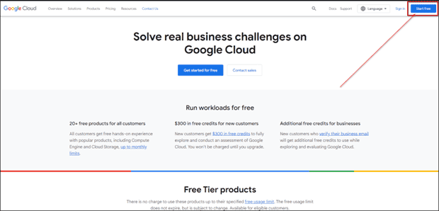

· Log in your Google account and fLill in the required information to create your account with free trial.

**Step 2: Create a New MySQL database**

· After logging in, access the following link to launch a MySQL server on Google Cloud Platform, this image has already been optimized by Bitnami.  
<https://console.cloud.google.com/marketplace/details/bitnami-launchpad/mysql>  
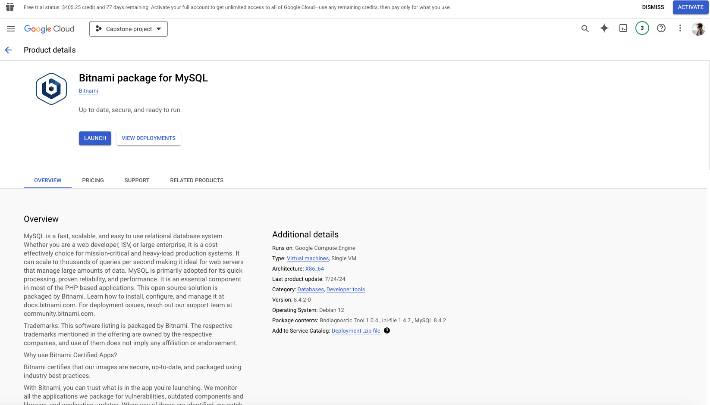

· Choose the preferred zone, machine type, and boot disk. The e2-micro type is often a good choice for testing and small projects, and Balanced Persistent Disk is strongly recommended for database workload for faster IO response time while not an expensive choice.  
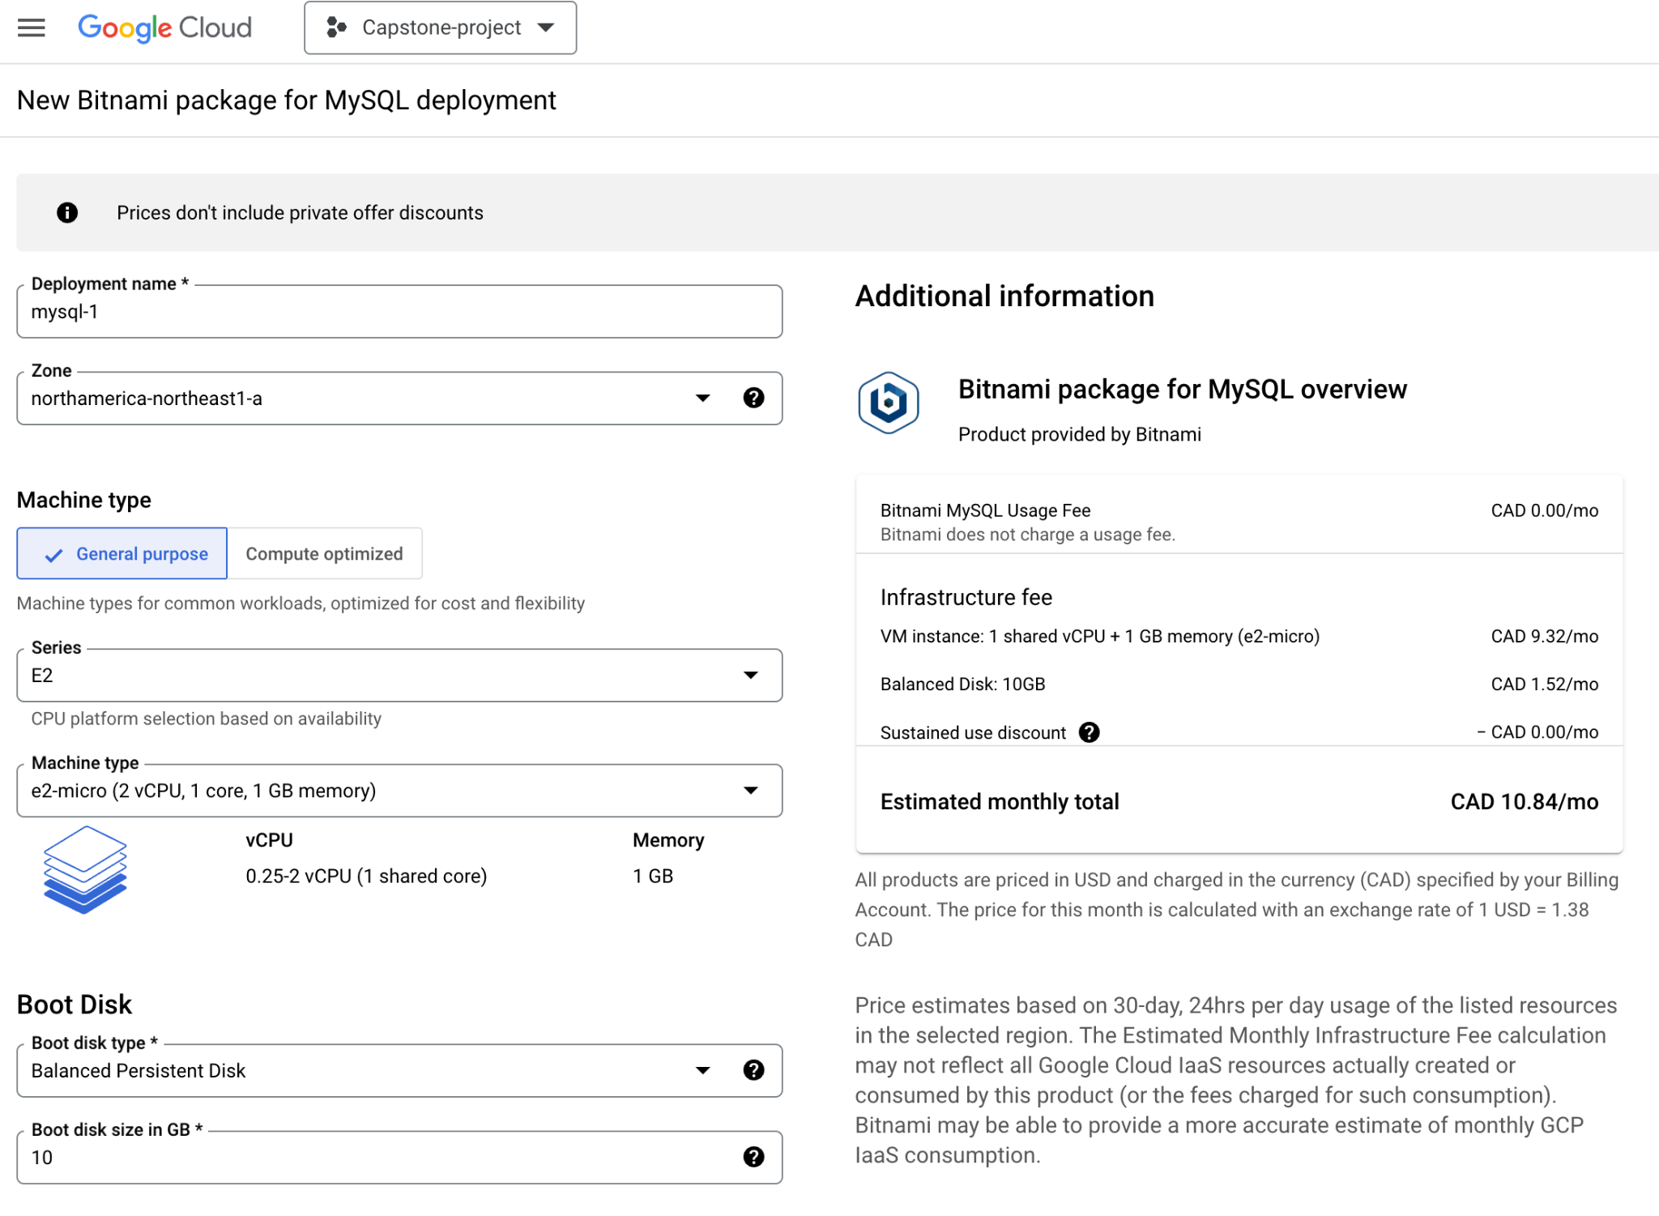

· Configure additional network settings such as network and External IP. Click "DEPLOY"

**Step 3: Wait for the Cluster to Deploy**

· It might take a few minutes for Google Cloud Platform to deploy your MySQL server. You can monitor the progress on the dashboard.

**Step 4: Update MySQL setting to allow external access**

· Click on "Computer Engine" in the left sidebar and then on the "SSH" button for your cluster.  
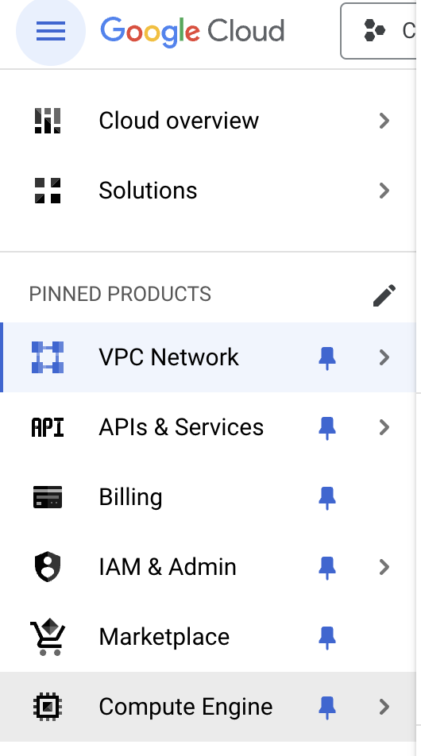  
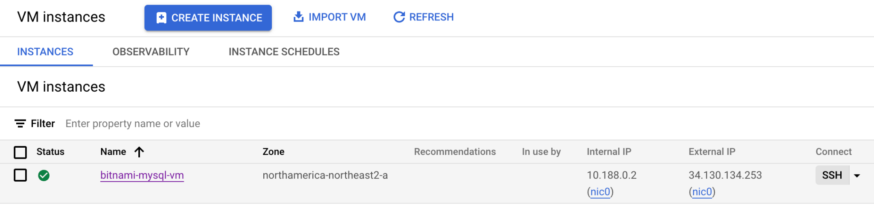

· Update the bitnami mysql setting from bind_address=127.0.0.1 to bind_address=0.0.0.0  
$ sudo sed -i 's/bind_address=127.0.0.1/bind_address=0.0.0.0/g' /opt/bitnami/mysql/conf/my.cnf

· Restart the mysql server to apply change  
$ sudo /opt/bitnami/ctlscript.sh restart

**Step 4: Whitelist Your IP Address**

· On the Google Cloud Console, click on "Firewall" in the left sidebar under the VPC Network category.  
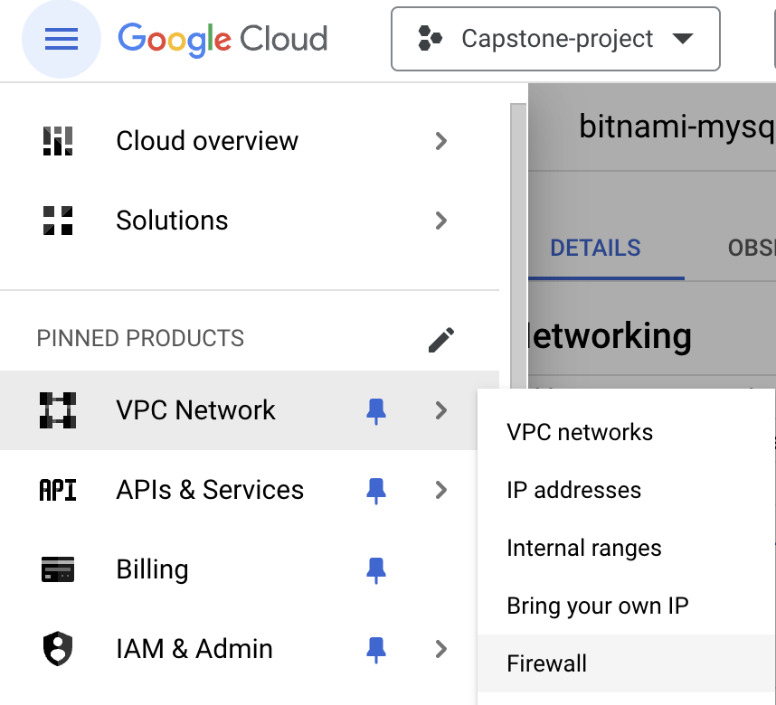

· Click on "CREATE FIREWALL RULE" and fill the following information:  
1. Your preferred rule name  
2. Target tags: bitnami-mysql-deployment  
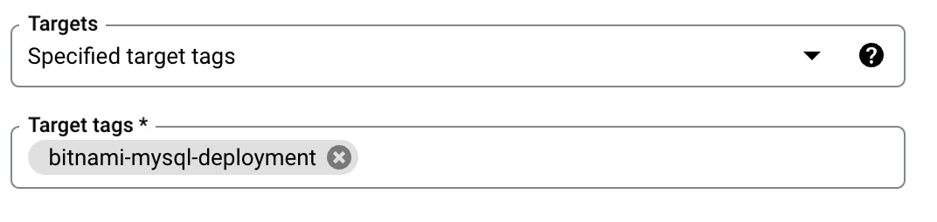  
3. Source IPv4 ranges: your IP address  
4. Check TCP and set port 3306  
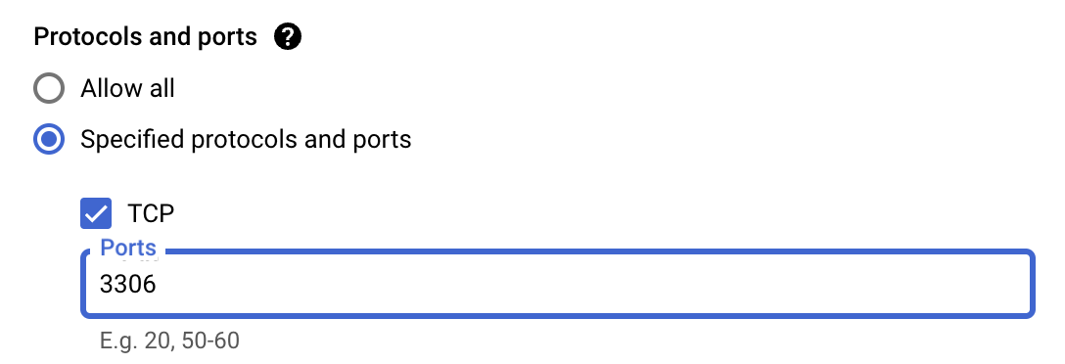  
5. Click “CREATE”

Then your mysql server is now open to your IP address, you can follow the next step to get login credentials to connect your mysql database.

**Step 6: Connect to Your MySQL server**

· Type in “Deployment Manager” in the search bar of the Google Cloud Console, then click the “Deployment Manager”  


· Click on your deployment name from the list of deployments

· You’ll find connection information at the right hand side.  
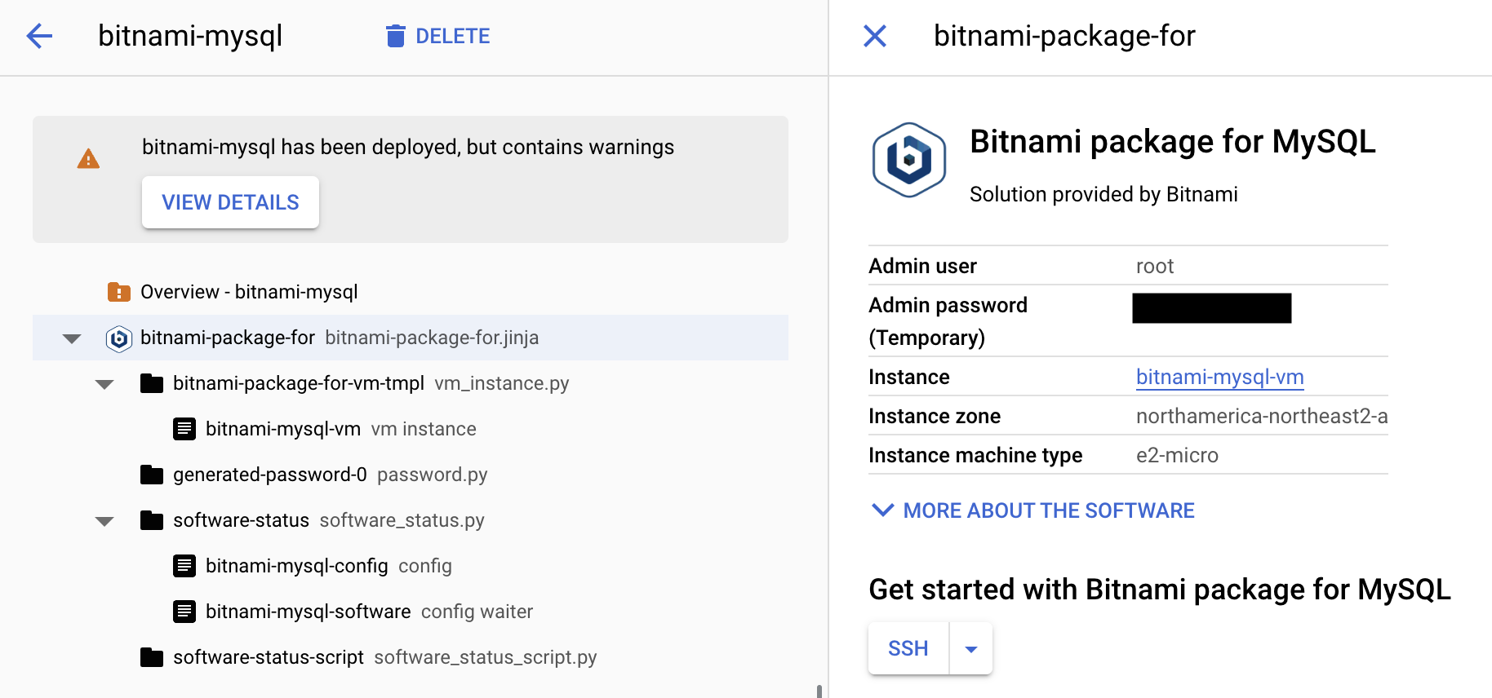

**Step 7: Update Your Application Configuration**

· Update your application configuration with the mysql user name, password and host IP.

## 

## Production Deployment on Google Cloud Platform Instructions

Follow these detailed steps to get your Conestoga Provincial Park website up and running on both the backend (Node.js and Express) and frontend using a single Google Cloud Platform Compute engine instance.  
  
**Backend Deployment (Node.js and Express)**

**Prerequisites:**

1. Make sure you followed previous guide to create the mysql database server

**Login into your mysql database server:** $ gcloud compute ssh "your-instance-name" --project "your-gcp-project-id"

**Install required packages:** $ sudo apt install git docker node  
 $ npm install -g npm

**Clone project repo:** $ git clone -b feature [git@github.com](mailto:git@github.com):Smars-Bin-Hu/capstone-project-dev.git

**Update mysql connection details in config/config.json**

**Build an Updated docker image:** $ docker build your-docker-image-name .

(Optional)**Push the updated docker image to dockerhub:** $ docker push your-docker-image-name

**Run the docker image:** $ docker run -p 8080:8080 -p 2000:2000your-docker-image-name

## 